**US Accidents Query Solutions**

***By Somendra, Pablo and Balaji***

## **Query 1**

WITH sev1 as(SELECT DISTINCT count(id) as Acc_Sev1, state

FROM us_accident_v3

WHERE severity = 1

GROUP BY state),

sev2 as(SELECT DISTINCT count(id) as Acc_Sev2, state

FROM us_accident_v3

WHERE severity = 2

GROUP BY state),

sev3 as(SELECT DISTINCT count(id) as Acc_Sev3, state

FROM us_accident_v3

WHERE severity = 3

GROUP BY state),

sev4 as(SELECT DISTINCT count(id) as Acc_Sev4, state

FROM us_accident_v3

WHERE severity = 4

GROUP BY state)

SELECT sev1.state, Acc_Sev1, Acc_Sev2, Acc_Sev3, Acc_Sev4

FROM sev1, sev2, sev3, sev4

WHERE sev1.state = sev2.state AND

sev2.state = sev3.state AND

sev3.state = sev4.state

ORDER BY sev1.state ASC;

## **Query 3**

SELECT DISTINCT

(SELECT avg(date_diff('second',start_time,end_time))

FROM us_accident_v3

WHERE severity = 4) AS Avg_dur_sev_4,

(SELECT stddev(date_diff('second',start_time,end_time))

FROM us_accident_v3

WHERE severity = 4) AS Stddev_dur_sev_4,

(SELECT max(date_diff('second',start_time,end_time))

FROM us_accident_v3

WHERE severity = 4) AS Max_dur_sev_4,

(SELECT avg(date_diff('second',start_time,end_time))

FROM us_accident_v3

WHERE severity = 3) AS Avg_dur_sev_3,

(SELECT stddev(date_diff('second',start_time,end_time))

FROM us_accident_v3

WHERE severity = 3) AS Stddev_dur_sev_3,

(SELECT max(date_diff('second',start_time,end_time))

FROM us_accident_v3

WHERE severity = 3) AS Max_dur_sev_3,

(SELECT avg(date_diff('second',start_time,end_time))

FROM us_accident_v3

WHERE severity = 2) AS Avg_dur_sev_2,

(SELECT stddev(date_diff('second',start_time,end_time))

FROM us_accident_v3

WHERE severity = 2) AS Stddev_dur_sev_2,

(SELECT max(date_diff('second',start_time,end_time))

FROM us_accident_v3

WHERE severity = 2) AS Max_dur_sev_2,

(SELECT avg(date_diff('second',start_time,end_time))

FROM us_accident_v3

WHERE severity = 1) AS Avg_dur_sev_1,

(SELECT stddev(date_diff('hour',start_time,end_time))

FROM us_accident_v3

WHERE severity = 1) AS Stddev_dur_sev_1,

(SELECT max(date_diff('second',start_time,end_time))

FROM us_accident_v3

WHERE severity = 1) AS Max_dur_sev_1

FROM us_accident_v3

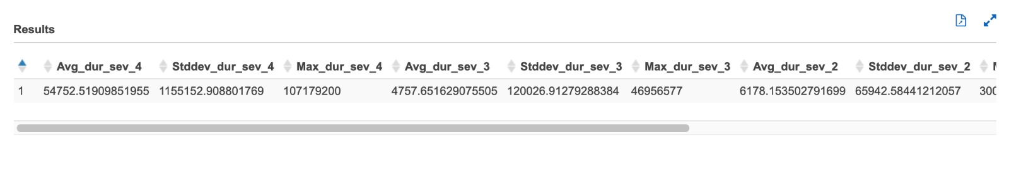

## **Query 4**

with cte1 as

(select date_format(start_time, '%Y-%m-%d') AS date,

weather_condition,

case

when weather_condition = 'Clear' then 'GOOD'

when weather_condition = 'Cloudy' then 'GOOD'

when weather_condition = 'Cloudy / Windy' then 'GOOD'

when weather_condition = 'Drizzle' then 'GOOD'

when weather_condition = 'Drizzle / Windy' then 'GOOD'

when weather_condition = 'Fair' then 'GOOD'

when weather_condition = 'Fair / Windy' then 'GOOD'

when weather_condition = 'Haze' then 'GOOD'

when weather_condition = 'Light Blowing Snow' then 'GOOD'

when weather_condition = 'Light Drizzle' then 'GOOD'

when weather_condition = 'Light Drizzle / Windy' then 'GOOD'

when weather_condition = 'Light Fog' then 'GOOD'

when weather_condition = 'Light Freezing Drizzle' then 'GOOD'

when weather_condition = 'Light Freezing Fog' then 'GOOD'

when weather_condition = 'Light Freezing Rain' then 'GOOD'

when weather_condition = 'Light Freezing Rain / Windy' then 'GOOD'

when weather_condition = 'Light Hail' then 'GOOD'

when weather_condition = 'Light Haze' then 'GOOD'

when weather_condition = 'Light Ice Pellets' then 'GOOD'

when weather_condition = 'Light Rain' then 'GOOD'

when weather_condition = 'Light Rain / Windy' then 'GOOD'

when weather_condition = 'Light Rain Shower' then 'GOOD'

when weather_condition = 'Light Rain Shower / Windy' then 'GOOD'

when weather_condition = 'Light Rain Showers' then 'GOOD'

when weather_condition = 'Light Sleet' then 'GOOD'

when weather_condition = 'Light Snow' then 'GOOD'

when weather_condition = 'Light Snow and Sleet' then 'GOOD'

when weather_condition = 'Light Snow Grains' then 'GOOD'

when weather_condition = 'Light Snow Shower' then 'GOOD'

when weather_condition = 'Light Snow Showers' then 'GOOD'

when weather_condition = 'Light Thunderstthen' then 'GOOD'

when weather_condition = 'Light Thunderstthen' then 'GOOD'

when weather_condition = 'Mist' then 'GOOD'

when weather_condition = 'Mostly Cloudy' then 'GOOD'

when weather_condition = 'Mostly Cloudy / Windy' then 'GOOD'

when weather_condition = 'N/A Precipitation' then 'GOOD'

when weather_condition = 'Overcast' then 'GOOD'

when weather_condition = 'Partial Fog' then 'GOOD'

when weather_condition = 'Partial Fog / Windy' then 'GOOD'

when weather_condition = 'Partly Cloudy' then 'GOOD'

when weather_condition = 'Partly Cloudy / Windy' then 'GOOD'

when weather_condition = 'Patches of Fog' then 'GOOD'

when weather_condition = 'Scattered Clouds' then 'GOOD'

when weather_condition = 'Shallow Fog' then 'GOOD'

when weather_condition = 'Showers in the Vicinity' then 'GOOD'

when weather_condition = 'Small Hail' then 'GOOD'

when weather_condition = 'Thunder in the Vicinity' then 'GOOD'

else 'BAD' end as weather_type

, severity

from us_accident_v3),

cte2 as

(select *,

case

when severity = 1 and weather_type = 'GOOD' then 's1_G'

when severity = 1 and weather_type = 'BAD' then 's1_B'

when severity = 2 and weather_type = 'GOOD' then 's2_G'

when severity = 2 and weather_type = 'BAD' then 's2_B'

when severity = 3 and weather_type = 'GOOD' then 's3_G'

when severity = 3 and weather_type = 'BAD' then 's3_B'

when severity = 4 and weather_type = 'GOOD' then 's4_G'

when severity = 4 and weather_type = 'BAD' then 's4_B'

else 'N/A' end as count_G_B

from cte1),

cte3 as(

select date,

count_G_B,

count(*) as totalNumber

from cte2

group by date,count_G_B

order by date,count_G_B asc),

cte4 as(

select a.date,

count_G_B,

a.totalNumber,

cast(a.totalNumber as double)*100/b.tot_accident_good as Acc_Percent

from cte3 a

inner join

(select date,

count(*) as tot_accident_good

from cte2

where weather_type = 'GOOD'

group by date) b

on a.date = b.date

where count_G_B in ('s1_G', 's2_G', 's3_G', 's4_G')),

cte5 as (

select a.date,

count_G_B,

a.totalNumber,

cast(a.totalNumber as double)*100/b.tot_accident_bad as Acc_Percent

from cte3 a

inner join

(select date, count(*) as tot_accident_bad from cte2

where weather_type = 'BAD'

group by date) b

on a.date = b.date where count_G_B in ('s1_B', 's2_B', 's3_B', 's4_B')),

cte6 as (

select * from cte4

union all

select * from cte5)

select date, q1['s1_G'] as Sev_1_perc_GOOD_weather,

q2['s2_G'] as Sev_2_perc_GOOD_weather,

q3['s3_G'] as Sev_3_perc_GOOD_weather,

q4['s4_G'] as Sev_4_perc_GOOD_weather,

q5['s1_B'] as Sev_1_perc_BAD_weather,

q6['s2_B'] as Sev_2_perc_BAD_weather,

q7['s3_B'] as Sev_3_perc_BAD_weather,

q8['s4_B'] as Sev_4_perc_BAD_weather

from (

select date, map_agg(count_G_B, Acc_Percent) q1,

map_agg(count_G_B, Acc_Percent) q2,

map_agg(count_G_B, Acc_Percent) q3,

map_agg(count_G_B, Acc_Percent) q4,

map_agg(count_G_B, Acc_Percent) q5,

map_agg(count_G_B, Acc_Percent) q6,

map_agg(count_G_B, Acc_Percent) q7,

map_agg(count_G_B, Acc_Percent) q8

from cte6

group by date

order by date)

## **Query 5**

**temperature**

select date, temp_range_in_f, severity, weather_condn, count(*) as cnt

from

(select date(start_time) as date,

case

when temperature between -80 and -71 then '-80 to -71'

when temperature between -70 and -61 then '-70 to -61'

when temperature between -60 and -51 then '-60 to -51'

when temperature between -50 and -41 then '-50 to -41'

when temperature between -40 and -31 then '-40 to -31'

when temperature between -30 and -21 then '-30 to -21'

when temperature between -20 and -11 then '-20 to -11'

when temperature between -10 and -1 then '-10 to -01'

when temperature between 0 and 9 then '0 to 9'

when temperature between 10 and 19 then '10 to 19'

when temperature between 20 and 29 then '20 to 29'

when temperature between 30 and 39 then '30 to 39'

when temperature between 40 and 49 then '40 to 49'

when temperature between 50 and 59 then '50 to 59'

when temperature between 60 and 69 then '60 to 69'

when temperature between 70 and 79 then '70 to 79'

when temperature between 80 and 89 then '80 to 89'

when temperature between 90 and 99 then '90 to 99'

when temperature between 100 and 109 then '100 to 109'

when temperature between 110 and 119 then '110 to 119'

when temperature between 120 and 129 then '120 to 129'

when temperature between 130 and 139 then '130 to 139'

when temperature between 140 and 149 then '140 to 149'

when temperature between 150 and 159 then '150 to 159'

when temperature between 160 and 169 then '160 to 169'

when temperature between 170 and 179 then '170 to 179'

else 'temperature unknown'

end as temp_range_in_f,

case

when weather_condition = 'Clear' then 'good'

when weather_condition like 'Cloudy%' then 'good'

when weather_condition = 'Drizzle' then 'good'

when weather_condition = 'Drizzle / Windy' then 'good'

when weather_condition like 'Fair%' then 'good'

when weather_condition = 'Haze' then 'good'

when weather_condition like 'Light%' then 'good'

when weather_condition = 'Mist' then 'good'

when weather_condition like 'Mostly%' then 'good'

when weather_condition = 'N/A Precipitation' then 'good'

when weather_condition = 'Overcast' then 'good'

when weather_condition like 'Partial%' then 'good'

when weather_condition like 'Partly%' then 'good'

when weather_condition = 'Patches of Fog' then 'good'

when weather_condition = 'Scattered Clouds' then 'good'

when weather_condition = 'Shallow Fog' then 'good'

when weather_condition = 'Showers in the Vicinity' then 'good'

when weather_condition = 'Small Hail' then 'good'

when weather_condition = 'Thunder in the Vicinity' then 'good'

else 'bad'

end as weather_condn, severity

from us_accident_v3

where year(start_time) = 2019 and month(start_time) = 12 and day(start_time) = 31

order by month(start_time), date(start_time))

group by weather_condn, severity, temp_range_in_f, date

order by temp_range_in_f, severity desc, weather_condn, cnt desc;

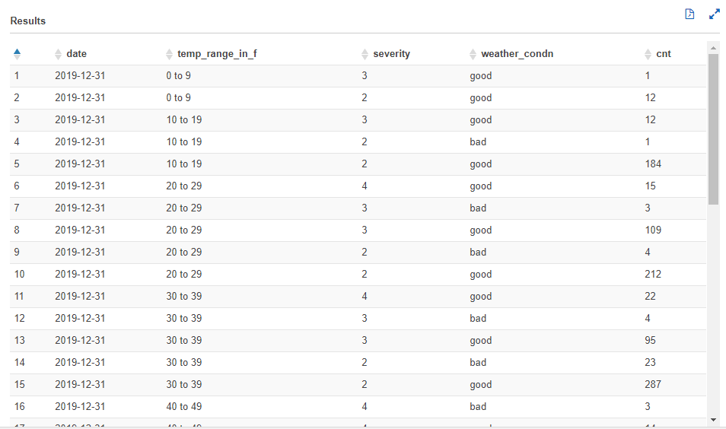

**visibility**

**wind-speed**

**Crossing**

select date, range, severity, weather_condn, count(*) as cnt

from

(select date(start_time) as date,

case

when crossing = false then '0'

when crossing = true then '1'

end as range,

case

when weather_condition = 'Clear' then 'good'

when weather_condition like 'Cloudy%' then 'good'

when weather_condition = 'Drizzle' then 'good'

when weather_condition = 'Drizzle / Windy' then 'good'

when weather_condition like 'Fair%' then 'good'

when weather_condition = 'Haze' then 'good'

when weather_condition like 'Light%' then 'good'

when weather_condition = 'Mist' then 'good'

when weather_condition like 'Mostly%' then 'good'

when weather_condition = 'N/A Precipitation' then 'good'

when weather_condition = 'Overcast' then 'good'

when weather_condition like 'Partial%' then 'good'

when weather_condition like 'Partly%' then 'good'

when weather_condition = 'Patches of Fog' then 'good'

when weather_condition = 'Scattered Clouds' then 'good'

when weather_condition = 'Shallow Fog' then 'good'

when weather_condition = 'Showers in the Vicinity' then 'good'

when weather_condition = 'Small Hail' then 'good'

when weather_condition = 'Thunder in the Vicinity' then 'good'

else 'bad'

end as weather_condn, severity

from us_accident_v3

where year(start_time) = 2019 and month(start_time) = 12 and day(start_time) = 31

order by month(start_time), date(start_time))

group by weather_condn, severity, range, date

order by range, severity desc, weather_condn, cnt desc;

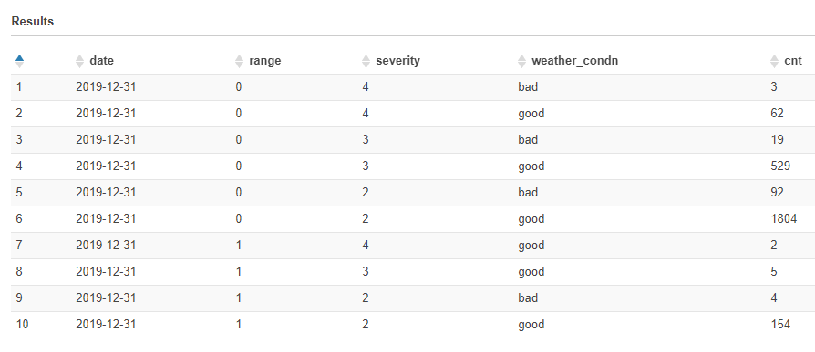

**Junction**

select date, range, severity, weather_condn, count(*) as cnt

from

(select date(start_time) as date,

case

when junction = false then '0'

when junction = true then '1'

end as range,

case

when weather_condition = 'Clear' then 'good'

when weather_condition like 'Cloudy%' then 'good'

when weather_condition = 'Drizzle' then 'good'

when weather_condition = 'Drizzle / Windy' then 'good'

when weather_condition like 'Fair%' then 'good'

when weather_condition = 'Haze' then 'good'

when weather_condition like 'Light%' then 'good'

when weather_condition = 'Mist' then 'good'

when weather_condition like 'Mostly%' then 'good'

when weather_condition = 'N/A Precipitation' then 'good'

when weather_condition = 'Overcast' then 'good'

when weather_condition like 'Partial%' then 'good'

when weather_condition like 'Partly%' then 'good'

when weather_condition = 'Patches of Fog' then 'good'

when weather_condition = 'Scattered Clouds' then 'good'

when weather_condition = 'Shallow Fog' then 'good'

when weather_condition = 'Showers in the Vicinity' then 'good'

when weather_condition = 'Small Hail' then 'good'

when weather_condition = 'Thunder in the Vicinity' then 'good'

else 'bad'

end as weather_condn, severity

from us_accident_v3

where year(start_time) = 2019 and month(start_time) = 12 and day(start_time) = 31

order by month(start_time), date(start_time))

group by weather_condn, severity, range, date

order by range, severity desc, weather_condn, cnt desc;

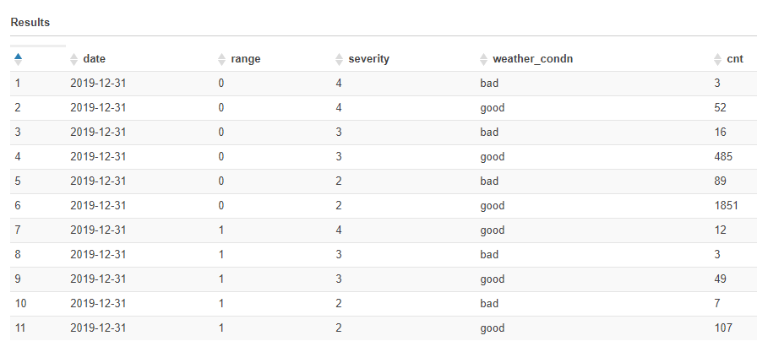

**Traffic_Signal**

select date, range, severity, weather_condn, count(*) as cnt

from

(select date(start_time) as date,

case

when traffic_signal = false then '0'

when traffic_signal = true then '1'

end as range,

case

when weather_condition = 'Clear' then 'good'

when weather_condition like 'Cloudy%' then 'good'

when weather_condition = 'Drizzle' then 'good'

when weather_condition = 'Drizzle / Windy' then 'good'

when weather_condition like 'Fair%' then 'good'

when weather_condition = 'Haze' then 'good'

when weather_condition like 'Light%' then 'good'

when weather_condition = 'Mist' then 'good'

when weather_condition like 'Mostly%' then 'good'

when weather_condition = 'N/A Precipitation' then 'good'

when weather_condition = 'Overcast' then 'good'

when weather_condition like 'Partial%' then 'good'

when weather_condition like 'Partly%' then 'good'

when weather_condition = 'Patches of Fog' then 'good'

when weather_condition = 'Scattered Clouds' then 'good'

when weather_condition = 'Shallow Fog' then 'good'

when weather_condition = 'Showers in the Vicinity' then 'good'

when weather_condition = 'Small Hail' then 'good'

when weather_condition = 'Thunder in the Vicinity' then 'good'

else 'bad'

end as weather_condn, severity

from us_accident_v3

where year(start_time) = 2019 and month(start_time) = 12 and day(start_time) = 31

order by month(start_time), date(start_time))

group by weather_condn, severity, range, date

order by range, severity desc, weather_condn, cnt desc;

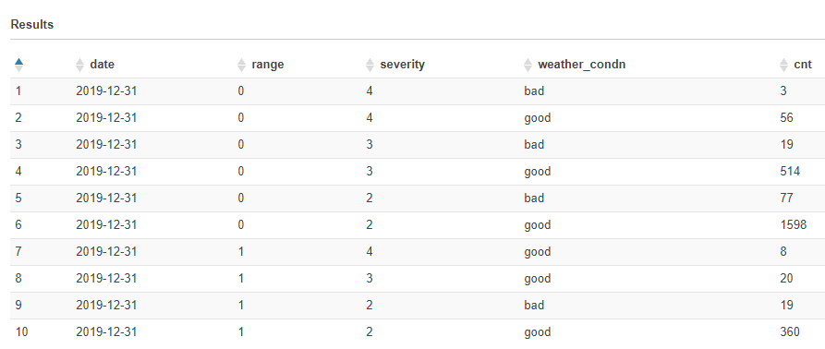

## Query 6

select count(id) as NumAcc, severity, extract(week from start_time) as week, extract(year from start_time) as year

from timezone_table us_accident_v3

where (extract(year from start_time) > 2015 and extract(month from start_time)>1) or

(extract(year from start_time) > 2016)

group by severity, extract(week from start_time), extract(year from start_time)

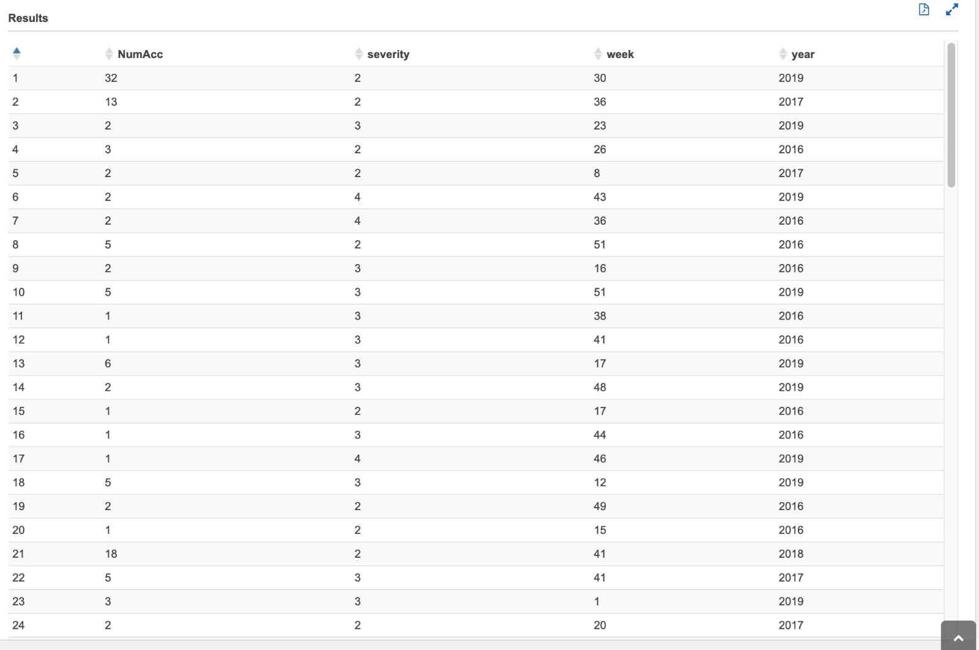

## Query 7

SELECT severity,

avg(distance) AS AvgDis,

stddev(distance) AS StdDevDis,

max(distance) AS MaxDis

FROM us_accident_v3

GROUP BY severity

ORDER BY severity

## Query 10

select Concept, sum(Frequency) as Freq from (with cte1 AS

(SELECT b.slno,

b.pattrn,

b.concpt,

cardinality(regexp_extract_all(lower(a.n_description),

lower(b.pattrn))) count

FROM us_accidents_dec_19_database.base_corpus3 a

CROSS JOIN us_accidents_dec_19_database.concept7 b

ORDER BY slno)

SELECT DISTINCT slno AS Serial_No,

concpt AS Concept,

pattrn AS Pattern,

sum(count)

OVER (partition by pattrn) AS Frequency

FROM cte1

ORDER BY slno) group by Concept

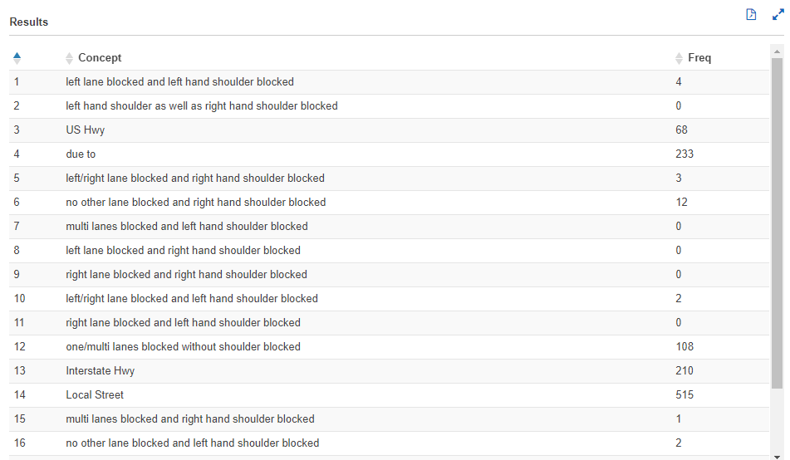

## Query 13

SELECT DISTINCT state,

date,

avg(sum_precip)

OVER (partition by date, state) AS avg_precip2

FROM

(SELECT DISTINCT state,

zipcode,

date,

sum(avg_precip)

OVER (partition by date, zipcode, state) AS sum_precip

FROM

(SELECT DISTINCT state,

zipcode,

date(start_time) AS date,

hour(start_time) AS hour,

minute(start_time) AS minute,

count(*) AS count,

avg(precipitation) AS avg_precip

FROM us_accidents_dec_19_database.us_accident_v3

GROUP BY state, zipcode, date(start_time), hour(start_time), minute(start_time)

ORDER BY count desc)

ORDER BY state, zipcode, date)

WHERE state = 'NY'

OR state = 'NJ'

OR state = 'PA'or state = 'IN'

OR state = 'WY'

ORDER BY state, date;

